**Financial Domain Query Report**

1. **Bank Loan Report - Summary**

**KPI’s:**

**Total Loan Applications:**

select count(id) as Total_Loan_Applications from financial_loan



**MTD Loan Applications:**

select count(id) as MTD_Loan_Applications from financial_loan

where month(issue_date) = 12 and year(issue_date) = 2021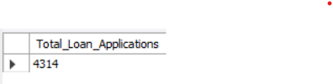

**PMTD Loan Applications:**

select count(id) as PMTD_Loan_Applications from financial_loan

where month(issue_date) = 11 and year(issue_date) = 2021

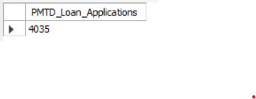

**Total Funded Amount:**

select sum(loan_amount) as Total_Funded_Amount from financial_loan

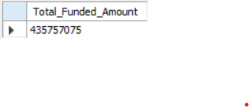

**MTD Total Funded Amount:**

select sum(loan_amount) as MTD_Total_Funded_Amount from financial_loan

where month(issue_date) = 12 and year(issue_date) = 2021

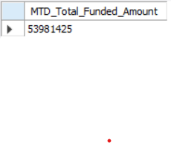

**PMTD Total Funded Amount:**

select sum(loan_amount) as PMTD_Total_Funded_Amount from financial_loan

where month(issue_date) = 11 and year(issue_date) = 2021

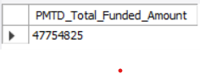

**Total Amount Received:**

select sum(total_payment) as Total_Amount_Received from financial_loan

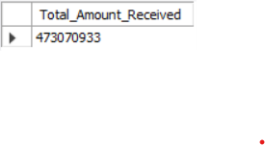

**MTD Total Amount Received:**

select sum(total_payment) as MTD_Total_Amount_Received from financial_loan

where month(issue_date) = 12 and year(issue_date) = 2021



**PMTD Total Amount Received:**

select sum(total_payment) as PMTD_Total_Amount_Received from financial_loan

where month(issue_date) = 11 and year(issue_date) = 2021

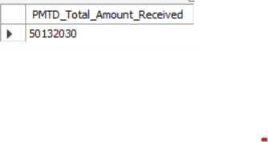

**Average Interest Rate:**

select avg(int_rate) * 100 as Average_Interest_Rate from financial_loan

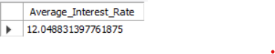

**MTD Average Interest Rate:**

select avg(int_rate) * 100 as MTD_Average_Interest_Rate from financial_loan

where month(issue_date) = 12 and year(issue_date) = 2021



**PMTD Average Interest Rate:**

select avg(int_rate) * 100 as PMTD_Average_Interest_Rate from financial_loan

where month(issue_date) = 11 and year(issue_date) = 2021



**Average DTI:**

select avg(dti) * 100 as Average_DTI from financial_loan



**MTD Average DTI:**

select avg(dti) * 100 as Average_DTI from financial_loan

where month(issue_date) = 12 and year(issue_date) = 2021

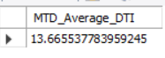

**PMTD Average DTI:**

select avg(dti) * 100 as Average_DTI from financial_loan

where month(issue_date) = 11 and year(issue_date) = 2021



**GOOD LOAN ISSUED:**

**Good Loan Percentage:**

select

(count(case when loan_status = "Fully Paid" or loan_status = "Current" then id end)*100) /

count(id) as Good_Loan_Percentage

from financial_loan



**Good Loan Applications:**

selectcount(id) as Good_Loan_Applications from financial_loan

where loan_status = "Fully Paid" or loan_status = "Current"

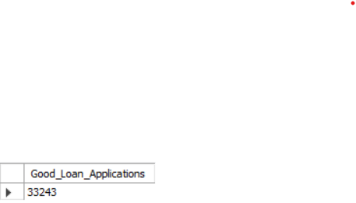

**Good Loan Funded Amount:**

selectsum(loan_amount) as Good_Loan_Funded_Amount from financial_loan

where loan_status = "Fully Paid" or loan_status = "Current"

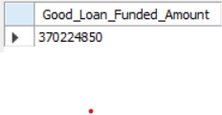

**Good Loan Amount Received:**

selectsum(total_payment) as Good_Loan_Amount_Received from financial_loan

where loan_status = "Fully Paid" or loan_status = "Current"

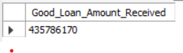

**BAD LOAN ISSUED:**

**Bad Loan Percentage:**

select

(count(case when loan_status = "Charged Off" then id end)*100) /

count(id) as Bad_Loan_Percentage

from financial_loan

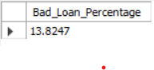

**Bad Loan Applications:**

selectcount(id) as Bad_Loan_Applications from financial_loan

where loan_status = "Charged Off"

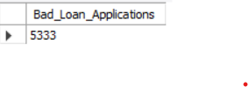

**Bad Loan Funded Amount:**

selectsum(loan_amount) as Bad_Loan_Funded_Amount from financial_loan

where loan_status = "Charged Off"

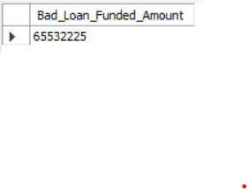

**Bad Loan Amount Received:**

selectsum(total_payment) as Bad_Loan_Amount_Received from financial_loan

where loan_status = "Charged Off"



**LOAN STATUS:**

select loan_status,

count(id) as Total_Loan_Aplications,

sum(loan_amount) as Total_Funded_Amount,

sum(total_payment) as Total_Amount_Received,

avg(int_rate) * 100 as Average_Interest_Rate,

avg(dti) * 100 as Average_DTI

from financial_loan

group by loan_status

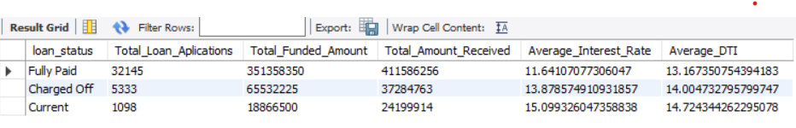

select loan_status,

sum(loan_amount) as Total_Funded_Amount,

sum(total_payment) as Total_Amount_Received

from financial_loan

where month(issue_date) = 12

group by loan_status

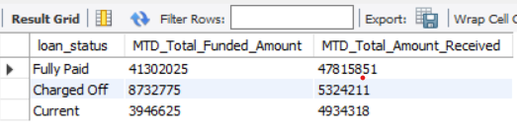

1. **Bank Loan Report – Overview**

**Month:**

select month(issue_date) as Month_Number,

monthname(issue_date) as Month_Name,

count(id) as Total_Loan_Applications,

sum(loan_amount) as Total_Loan_Funded_Amount,

sum(total_payment) as Total_Loan_Amount_Received

from financial_loan

group by month(issue_date), monthname(issue_date)

order by month(issue_date)

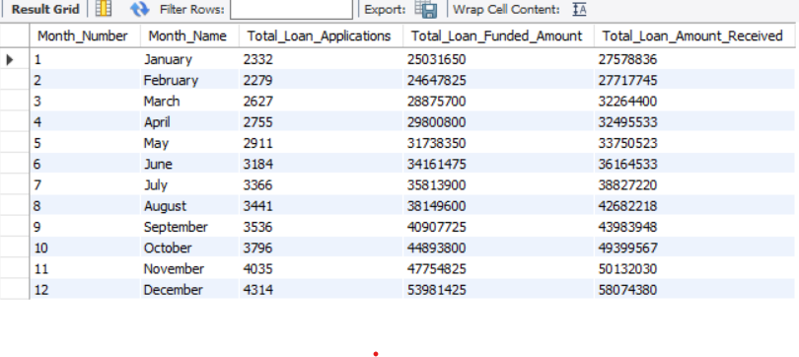

**State:**

select address_state as State,

count(id) as Total_Loan_Applications,

sum(loan_amount) as Total_Loan_Funded_Amount,

sum(total_payment) as Total_Loan_Amount_Received

from financial_loan

group by address_state

order by address_state

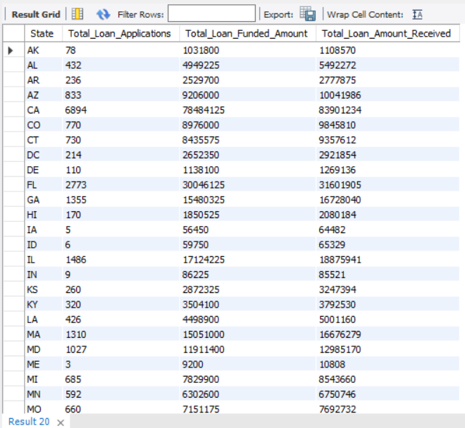

**Term:**

select term as term,

count(id) as Total_Loan_Applications,

sum(loan_amount) as Total_Loan_Funded_Amount,

sum(total_payment) as Total_Loan_Amount_Received

from financial_loan

group by term

order by term

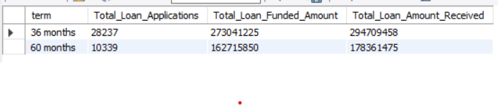

**Employee Length:**

select emp_length as Employee_Length,

count(id) as Total_Loan_Applications,

sum(loan_amount) as Total_Loan_Funded_Amount,

sum(total_payment) as Total_Loan_Amount_Received

from financial_loan

group by emp_length

order by emp_length

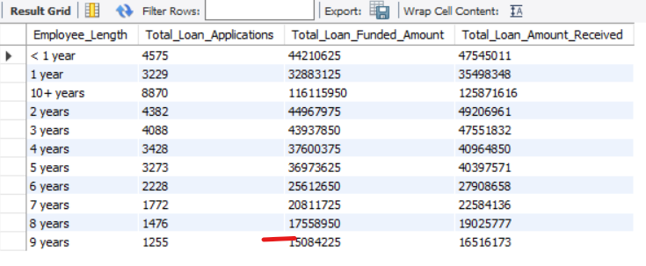

**Purpose:**

select purpose as Purpose,

count(id) as Total_Loan_Applications,

sum(loan_amount) as Total_Loan_Funded_Amount,

sum(total_payment) as Total_Loan_Amount_Received

from financial_loan

group by purpose

order by purpose

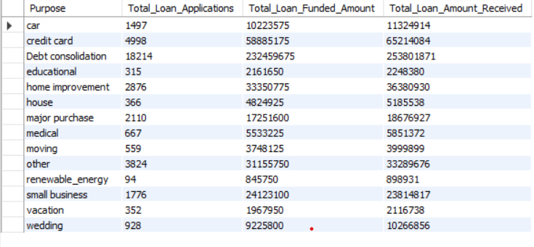

**Home Ownership:**

select home_ownership as Home_Ownership,

count(id) as Total_Loan_Applications,

sum(loan_amount) as Total_Loan_Funded_Amount,

sum(total_payment) as Total_Loan_Amount_Received

from financial_loan

group by home_ownership

order by home_ownership

